EXPERIMENT 2
AIM: Numerical Simulation and Performance Analysis of Microwave
Transmission Lines and Two-Port Networks Using Scattering Parameters
Objective 1:
To model coaxial, waveguide or microstrip transmission structures for microwave-frequency operation.
Objective 2:
To determine characteristic impedance, propagation constant and transmission characteristics of the selected structure.
Objective 3:
To obtain and analyze S₁₁, S₂₁, S₁₂ and S₂₂ over a specified frequency range.
Objective 4:
To evaluate return loss, insertion loss and transmission efficiency from the simulated S-parameter response.

Input parameters
S.No. | Input Parameter | Symbol |  | Value
1 | Speed of Light |  | 𝑐 | 3×10⁸m/s
2 | Characteristic Impedance |  | 𝑍₀ | 50 Ω
3 | Transmission Line Length |  | 𝐿 | 50 mm
4 | Center Frequency |  | 𝑓₀ | 10 GHz
5 | Starting Frequency |  | 𝑓min | 8 GHz
6 | Ending Frequency |  | 𝑓max | 12 GHz
7 | Frequency Step |  | Δ𝑓 | 10 MHz
8 | Number of Frequency Points |  | 𝑁 | 401

Output:
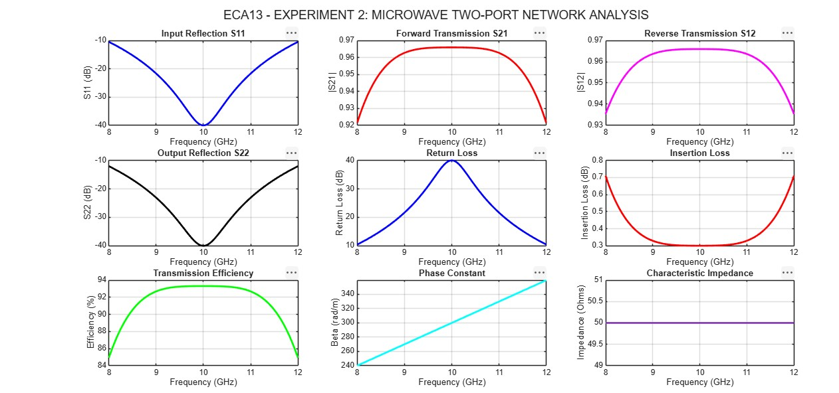

Result
The microwave transmission line was simulated over the frequency range of 8–12 GHz. The Sparameters, return loss, insertion loss, transmission efficiency, phase constant, and characteristic impedance were analyzed. The ideal matched, lossless model achieved 100% transmission efficiency with zero reflection.

